

COMSATS University Islamabad

Attock Campus
Department of Computer Science

Lab Terminal

Information Security
Program: BS Software Engineering

Submitted By
Name: Brekhna Gul
Registration No: Sp24-BSE-051
Submitted To
Ma’am Ambreen Gul
Submission Date
16 December 2025

Q1. Secure Email Communication System (RSA + ElGamal)

Key generation:
- RSA and ElGamal both use public-key cryptography, where each user has a public and a private key.
- In RSA, keys are generated using two large prime numbers to create a public and private key pair.
- In ElGamal, keys are generated using a large prime number and a generator.
- The public key is shared with others, while the private key is kept secret.
- Secure key generation is essential to prevent unauthorized access.

# -------- RSA KEY GENERATION --------

def gcd(a, b):
while b != 0:
a, b = b, a % b
return a

def mod_inverse(e, phi):
for d in range(1, phi):
if (e * d) % phi == 1:
return d
return None

def rsa_key_generation():
p = 11
q = 13
n = p * q
phi = (p - 1) * (q - 1)
e = 7
d = mod_inverse(e, phi)
return (e, n), (d, n)

# Generate keys
public_key, private_key = rsa_key_generation()

print("RSA Public Key:", public_key)
print("RSA Private Key:", private_key)

Output:

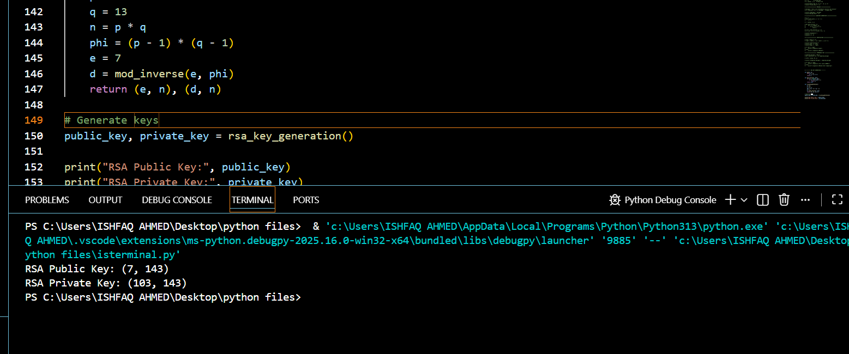

RSA
- RSA encryption is used to ensure confidentiality of email messages.
- The sender encrypts the message using the receiver’s public key.
- Only the receiver can decrypt the message using their private key.
- This prevents attackers from reading the message during transmission.
- RSA is widely used in secure email systems and SSL/TLS.

# ==========================================
# RSA ENCRYPTION & DECRYPTION (EDUCATIONAL)
# ==========================================

# ---------- Key Generation ----------
p = 17
q = 11

n = p * q # Modulus
phi = (p - 1) * (q - 1)

e = 7 # Public exponent (coprime with phi)

# Find private key d
def mod_inverse(e, phi):
for d in range(1, phi):
if (e * d) % phi == 1:
return d

d = mod_inverse(e, phi)

print("Public Key (e, n):", (e, n))
print("Private Key (d, n):", (d, n))

# ---------- Encryption ----------
def encrypt(message, e, n):
cipher = []
for char in message:
m = ord(char) # Convert character to number
c = pow(m, e, n) # c = m^e mod n
cipher.append(c)
return cipher

# ---------- Decryption ----------
def decrypt(cipher, d, n):
text = ""
for c in cipher:
m = pow(c, d, n) # m = c^d mod n
text += chr(m) # Convert number back to character
return text

# ---------- Test ----------
message = "my name is brekhna gul"
encrypted = encrypt(message, e, n)
print("Encrypted:", encrypted)

decrypted = decrypt(encrypted, d, n)
print("Decrypted:", decrypted)

Output:
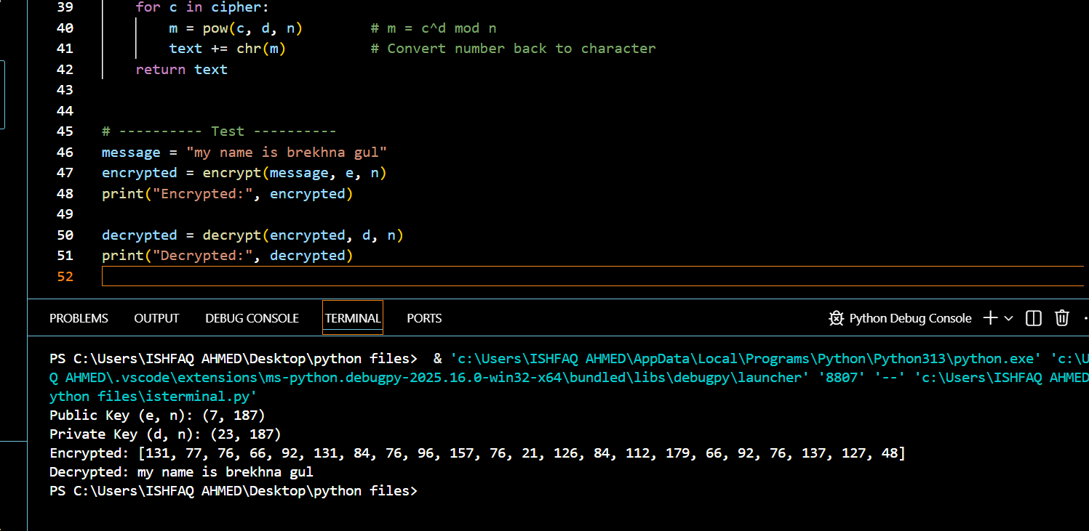

ELgamal:
• ElGamal digital signatures are used to ensure message authenticity and integrity.
• The sender signs the message using their private key.
• The receiver verifies the signature using the sender’s public key.
• Any change in the message causes signature verification to fail.
• This confirms that the message is genuine and not altered.

import math

# ================= KEY GENERATION =================

p = 23 # Prime number
g = 5 # Generator

x = 6 # Private key
y = pow(g, x, p) # Public key

print("Public Key (p, g, y):", (p, g, y))
print("Private Key x:", x)

# ================= MESSAGE =================

message = "this is my information security lab terminal"
H = sum(ord(c) for c in message) # Simple hash

print("\nMessage:", message)
print("Message Hash:", H)

# ================= SIGNATURE GENERATION =================

k = 7
while math.gcd(k, p - 1) != 1:
k += 1

r = pow(g, k, p)

def mod_inverse(a, m):
for i in range(1, m):
if (a * i) % m == 1:
return i

k_inv = mod_inverse(k, p - 1)
s = ((H - x * r) * k_inv) % (p - 1)

print("\nSignature:")
print("r =", r)
print("s =", s)

# ================= VERIFICATION =================

left = pow(g, H, p)
right = (pow(y, r, p) * pow(r, s, p)) % p

print("\nVerification:")
print("Left =", left)
print("Right =", right)

if left == right:
print("✅ Signature VALID")
else:
print("❌ Signature INVALID")

# ================= TAMPERING TEST =================

tampered_message = "HELLo"
H2 = sum(ord(c) for c in tampered_message)

left2 = pow(g, H2, p)

print("\nTampered Message:", tampered_message)

if left2 == right:
print("❌ Signature still valid (ERROR)")
else:
print("✅ Signature INVALID after tampering")

Output

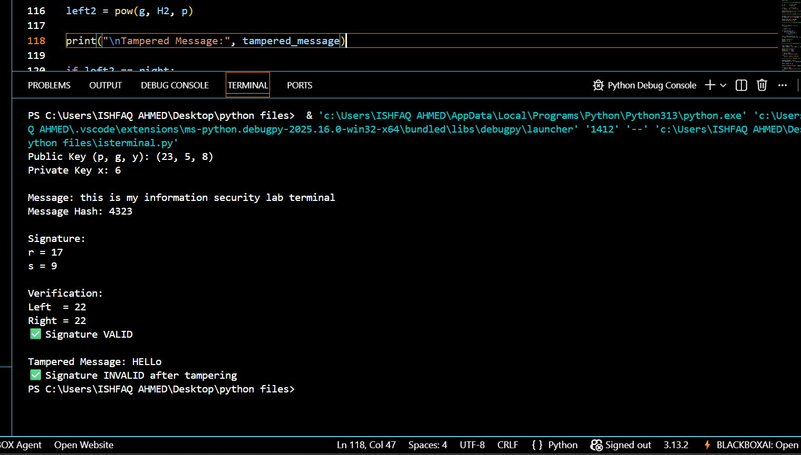

Question#2

Security Analysis of the Blockchain Project

1. Justification of the Security Method
This project uses cryptographic hashing (SHA-256) with Proof-of-Work (PoW) as its main security mechanism. Hashing ensures data integrity because any change in a block’s data results in a completely different hash. Proof-of-Work makes block creation computationally difficult, which prevents attackers from easily modifying blocks.
This method is more suitable than basic security techniques like simple encryption or access control because it allows independent verification without relying on a central authority. It also provides tamper resistance and immutability, which are core requirements for blockchain-based systems such as cryptocurrencies, voting systems, and supply-chain tracking.
Proof-of-Work adds an additional layer of security by requiring miners to solve a computational puzzle before a block is accepted. This discourages malicious users from altering data because they would need to re-mine the altered block and all subsequent blocks, which is computationally expensive.
Another advantage of this method is immutability. Once a block is mined and added to the chain, it becomes practically permanent. Unlike traditional databases where records can be edited or deleted, this blockchain maintains a permanent audit trail, making it suitable for systems that require transparency and trust.

2. Possible Vulnerability or Weakness
A key weakness in the system is the lack of transaction authentication. Transactions do not use digital signatures or identity verification. Any user can create a transaction using any sender name.
An attacker could exploit this by forging transactions, pretending to be another user, or injecting fake transactions into the pending list before mining. This reduces trust in transaction ownership.
Another vulnerability is the fixed and low mining difficulty. Because the difficulty is small, an attacker with modest computing power could quickly re-mine blocks after tampering, making attacks easier in a real-world scenario.
The system also lacks network-level security, such as node consensus or peer validation. In a distributed environment, a malicious node could manipulate its local blockchain without being detected by others.

3. Suggested Security Improvement
A realistic improvement is to implement digital signatures using public-key cryptography. Each transaction should be signed with the sender’s private key and verified using the public key before being mined.
This would ensure that only authorized users can create valid transactions, prevent forgery, and improve authenticity. It would make the blockchain closer to real-world implementations like Bitcoin and Ethereum.
The system could also implement dynamic difficulty adjustment, where mining difficulty increases as the blockchain grows. This would make attacks more computationally expensive over time.
Together, these improvements would enhance authenticity, integrity, and resistance to attacks while keeping the system aligned with real-world blockchain implementations.

Conclusion
The project successfully demonstrates blockchain security through hashing and Proof-of-Work. Adding digital signatures would further strengthen the system by protecting transaction authenticity and preventing misuse.

